|  |
| --- |
| Circle Language Spec: System Objects |

## System Command Call Notations

### Introduction

There might be several notations for calling a system command.

Direct calls to **Get**, **Set** and **Use** commands might not usually be seen. Those system commands may usually be called indirectly by *assignment* commands.

But being introduced to using **Get** and **Set** commands, instead of a single assignment call, might give a lower-level view on assignment. This lower-level perspective might be of use when wanting to use alternative forms of assignment, that do not seem to fit into an assignment notation.

### Notational Choices

#### Distinguishing Object-Bound and Reference-Bound Aspects

There are system commands that apply to object references and to the object itself. System commands, that apply to an object reference are displayed here with a parent around the targeted reference:

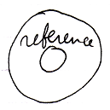

System commands, that apply to the object itself are displayed without a parent around the targeted object.

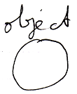

#### System Interface Call Notation

One of the notations for system command calls is calling upon the command definition in the system interface:

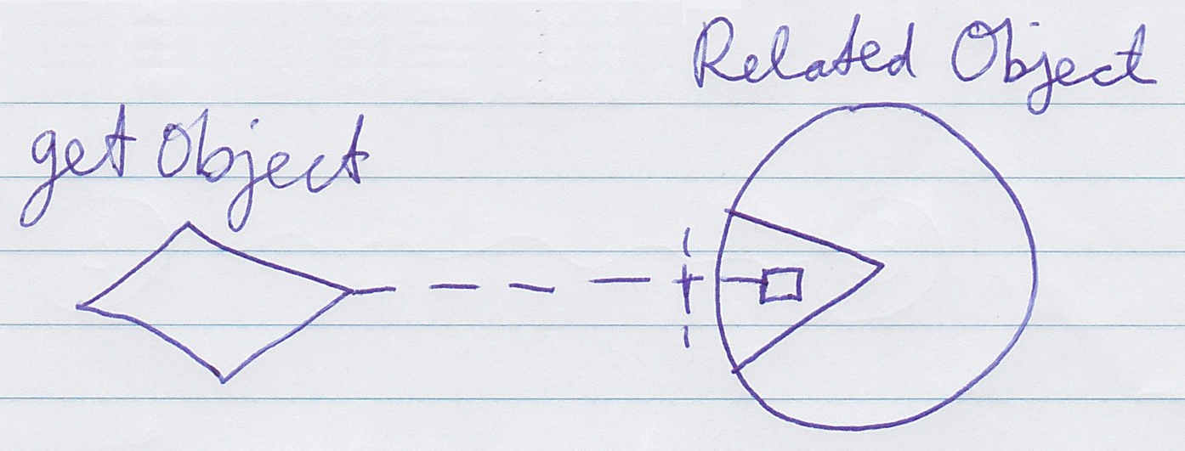

This might be a regular way to display a command call in Circle, but now a call to a command inside the system interface.

There could be multiple ways to display the content of the system interface. They might depend on taste, application or needs. This article may go for a system interface that looks relatively simple with often a loose square in it representing a system command.

### System Interface Calls versus Assignment

System command calls to **Get**, **Set** or **Use** might not often be visible, because they might usually be implied by assignment calls. But for alternative types of assignment, that do not have a standard assignment notation, you can explicitly display **Get**, **Set** and **Use** calls. When a simpler notation does not suffice, displaying **Get**, **Use** or **Set** command explicitly might be needed. This basically only happens in unusual cross-aspect assignments. In abstract diagram expression though, you can always use the explicit notations to simply make a point.

### System Interface Calls

Here is an attempt to systematically display all the system commands thusfar in a system interface command call notation. Where the calls look similar this might be relevant to realize, where the calls look particular this might be relevant to realize as different. Which are similar and which are different might become apparent from this full overview.

|  |  |
| --- | --- |
|  |  |
| (has assignment notation) | (has assignment notation) |
|  |  |
|  |  |
| (has assignment notation) | (has assignment notation) |
|  |  |
|  |  |
| (object-bound)  (has cross-aspect assignment notation) | (reference-bound)  (has cross-aspect assignment notation) |
|  |  |
|  |  |
| (has assignment notation) | (has assignment notation) |
|  |  |
|  |  |
|  |  |
|  |  |
|  |  |
|  |  |
|  |  |
|  |  |
| (also has a basic command call notation) |  |

## WAS HERE

### System Interface Calls with Arguments

Above were shown the basic system command call notation, but most system command calls are incomplete without an argument.

The **Object Get** command has a return value: the object. It is an *output* argument. It should be there to transfer the **Object** aspect to another symbol. The **Object Get** command's return value is drawn out as follows.

<Picture of Object Get with argument?>

In the picture above the output argument of the **Object Get** call is filled in. **Object Get** is called upon the smaller circle contained by the larger circle. But next, an **Object Set** is *implicitly* called upon the smaller circle in the corner. The diagram above implicitly causes an **Object Set** to be executed upon the smaller circle in the corner.

Something similar happens in case of an **Object Set** command. Here is the basic notation of an **Object Set** command call:

<Picture of Object Set without an argument?>

And here the argument of the **Object Set** command is filled in:

<Picture of Object Set with an argument?>

This causes an implicit **Object Get** on the smaller circle in the top-right corner, followed by the explicit **Object Set**, targeting the smaller circle contained by the larger circle.

So the basic display of a basic system command call with an argument filled in, implictly causes another system command to be called as well.

Below you will find an overview of all the system commands with their argument filled in. Which system commands are implicitly called, is also made clear in the overview.

Some commands might not be covered by assignment notation, which might make explicit calls needed. Others might be possible with an assignment notation also, which the table below also attempts to mention.

|  |  |
| --- | --- |
|  |  |
| **Object Get 🡨**  **(Object Set 🡪)** | **(Object Get 🡪)**  **Object Set 🡨** |
| (has assignment notation) | (has assignment notation) |
|  |  |
|  | *(Might not have a system interface call with argument notation, because implicit Get Class might not be a thing.)* |
| **Use As Class (≈ Object Get) 🡨 (Class Set 🡪)** | **(Class Get 🡪)**  **Class Set 🡨** |
| (has assignment notation) |  |
|  |  |
|  |  |
| **Object-Bound Class Get 🡨**  **(Class Set 🡪)** | **Reference-Bound Class Get 🡨**  **(Class Set 🡪)** |
|  |  |
|  |  |
| **(Use As Class (≈ Object Get) 🡪)**  **Class Set 🡨** |  |
| (has assignment notation) |  |
|  |  |
|  |  |
| **Object-Bound Class Get 🡨**  **(Object Set 🡪)** | **Reference-Bound Class Get 🡨**  **(Object Set 🡪)** |
| (has cross-aspect assignment notation) | (has cross-aspect assignment notation) |
|  |  |
|  |  |
| **Value Get 🡨**  **(Value Set 🡪)** | **(Value Get 🡪)**  **Value Set 🡨** |
| (has assignment notation) | (has assignment notation) |

### <Old>

|  |  |  |
| --- | --- | --- |
| Clone (2) Get | Clone (2) Set |  |
|  |  |  |
| Clone (2) Get 🡨  (Clone (2) Set 🡪) | (Clone (2) Get 🡪)  Clone (2) Set 🡨 |  |
|  |  |  |
|  |  |  |
| New |  |  |
|  |  |  |
| (Use As Class 🡪)  New 🡨 |  |  |
|  |  |  |
|  |  |  |
| Add |  |  |
|  |  |  |
| (Object Get 🡪)  Add 🡨 |  |  |

### Practical System Call Notation Example: Class Get – Class Set

When you look at the aspects introduced so far, the only time you might need the ‘system command with argument’ notation for **Gets** and **Sets**, is in a **Class Get – Class Set** assignment.

This creates the following notations of the different ways to use a class:

|  |
| --- |
| Class Assignment |
|  |
| Use As Class 🡨  Class Set 🡪 |
|  |
| Class to Object Assignment |
|  |
| Class Get 🡨  Object Set 🡪 |
|  |
| Class Get – Class Set Assignment: |
|  |
|  |
| <Might change to a more explicit notation.>  Class Get 🡨  Class Set 🡪 |

### Explicit Get & Set

Assignment has a special, simplified notation covered in the *Assignment* article. But you can also display the **Get** and **Set** of the assignment explicitly. This notation is only required when there is no simplified notation available for what you want. However, explicit notation of **Get** and **Set** can always be used in *abstract* diagram expression just to make a point.